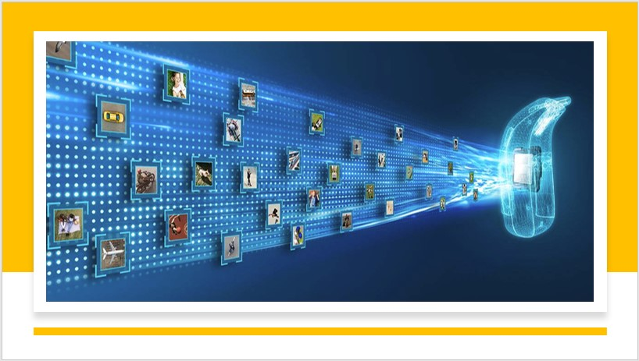
Automatic Image captioning
Group - 15

Automatically describing the content of an image is a fundamental problem in artificial intelligence that connects computer vision and natural language processing.
Team:
Hanumanth Sangewar, Raheem Baig, Ritesh K Singh

Problem Statement:
Build an image captioning model to generate captions of an image using CNN.
Literature Review:
Image captioning is the task of transforming objects into words. An Image captioning model's job is to provide a natural language description of the content in an image. Not only that, but it also needs to capture how the objects are related to each other, their attributes and the activities they are involved.
Image captioning spans the fields of computer vision and natural language processing. The image captioning task generalizes object detection where the descriptions are a single word. Recently, most research on image captioning has focused on deep learning techniques, especially Encoder-Decoder models with Convolutional Neural Network (CNN) feature extraction.
Approaches to image captioning can be divided into the following categories [2]:
- Systems that rely on computer vision techniques to extract object detections and features from the source image, using these as input to a Natural Language Generation stage.
- Systems that frame the task as a retrieval problem, where a caption, or parts thereof, is identified by computing the proximity/relevance of strings in the training data to a given image. This is done by exploiting either a unimodal or multimodal space. Many retrieval-based approaches rely on neural models to handle both image features and linguistic information.
- Systems that also rely on neural models, but rather than performing partial or wholesale caption retrieval, generate novel captions using a recurrent neural network (RNN), usually a long short-term memory (LSTM). Typically, such models use image features extracted from a pre-trained convolutional neural network (CNN) such as the VGG CNN to bias the RNN towards sampling terms from the vocabulary in such a way that a sequence of such terms produces a caption that is relevant to the image.
- Most conventional systems also utilize an encoder-decoder framework, in which an input image is encoded into an intermediate representation of the information contained within the image, and subsequently decoded into a descriptive text sequence. This encoding can consist of a single feature vector output of a CNN, or multiple visual features obtained from different regions within the image. In the latter case, the regions can be uniformly sampled, or guided by an object detector which has been shown to yield improved performance.
Image Captioning can be regarded as an end-to-end Sequence to Sequence problem, as it converts images, which are regarded as a sequence of pixels to a sequence of words. For this purpose, we need to process both the language or statements and the images.

If someone is asked to describe this image one would describe it as: “A dog wearing pink glasses in front of a blue wall sitting on a white towel”. So, how are we doing this? While forming the description, we are seeing the image but at the same time, we are looking to create a meaningful sequence of words. The first part is handled by CNNs.
CNN sample architecture
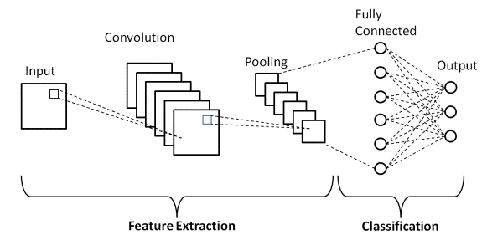

and the second is handled by RNNs.

RNN sample architecture
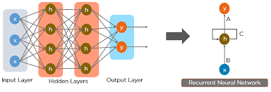
If we can obtain a suitable dataset with images and their corresponding human descriptions, we can train networks to automatically caption images. FLICKR 8K, FLICKR 30K, and MS-COCO are some most used datasets for this purpose.
Model & Implementation:
For our Project, we would be using Flickr_8K dataset. It is a collection of sentence-based image descriptions. It consists of 8k images in JPEG format with different shapes and sizes. All images are paired with five different captions which provide clear descriptions of the salient entities and events.
Our model would consist of a multimodal neural network using feature vectors obtained from both RNN and CNN networks. The CNN network would be fed with the images that we need to describe. The input to the RNN network would be the words in the text sequence produced till now as a sequence. Now, the question arises how or in what order should we introduce the pieces of information into our model? To accomplish this, we can take the help of multiple architectures proposed by Marc Tanti & Albert Gatt in their research paper titled “Where to put the Image in an Image Caption Generator” [1].
Following are the architectures proposed in their paper.
- Injecting Architecture: In this type, the image data is introduced along with the language data, and the image and language data mixture is represented together. The RNN trains on the mixture. So, at every step of training, the RNN uses the mixture of both pieces of information to predict the next word, and consequently, the RNN finetunes image information as well during training.
  - Init-Inject: An image feature vector is obtained from CNN having the same dimension as the RNN's hidden state vector and passed as the initial state of RNN.
  - Pre-Inject: An image feature vector is passed as the first word to RNN
  - Par-Inject: An image vector & word vector are merged into a similar size embedding and passed to be trained by RNN.
- Merging: the image data is not introduced in the RNN network. So, the image and the language information are encoded separately and introduced together in a feed-forward network, creating a multimodal layer architecture.
Proposed Approach:
Our approach would be to initially start with a base model and attempt to incorporate the following approach towards the latter half of the project, as per Marc Tanti and Albert Gatt's Image Captioning model proposed in their research paper [1].
- Take a trained neural network and input an image and a matching caption.
- Record the multimodal vector in the neural network at every time step.
- Replace the image from the original neural network in step 1 with a randomly selected image, paired with the original caption, thus introducing an image-caption mismatch.
- Record the new, adulterated multimodal vector at every time-step for the new caption-image combination.
- Compare the original and adulterated vectors: if these converge as more words are fed to the model, it implies that the multimodal vector is losing image information, as it would be getting influenced less by the image and more by the prefix.
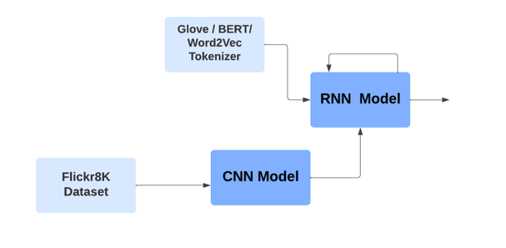

Conclusion:
Our goal is to train the model using Flickr8k dataset and the model should be able to identify and caption images based on the various objects depicted in it by mapping the regions as well.
Challenges:
- Although it may be tough, a single end-to-end model can be less complex instead of a multimodal neural network model consisting of a CNN & RNN.
- Real world applicability: Automatic Image Captioning usability is multifold in today's AI-Centric world. Some examples listed below:
- Accessibility: It can help people with low or no eyesight in identify images by providing them with textual descriptions of images. This enables them to understand and engage with visual content on the internet or in digital media.
- Virtual Assistants: Image Captioning can be integrated into virtual assistants such as smart glasses or camera-based systems, to provide real-time descriptions of the user's surroundings. It can also help individuals with visual impairments in navigating unfamiliar environments or recognizing objects.
- Image Indexing: It can be used to index and retrieve images based on their content. By generating captions for images, it becomes easier to search for specific images using text-based queries, improving the efficiency of image retrieval systems.
- User Experience on Web: Image captioning can enhance user experiences on social media platforms and e-commerce websites. Captions can be automatically generated for user-uploaded images, making them more accessible and understandable. This allows for improved search functionality and helps users find relevant content more effectively.
- Medical Analysis: It can be valuable in medical imaging analysis. By generating captions for medical images, it becomes easier for healthcare professionals to review and interpret images, improving diagnosis, treatment planning, and medical research.
- Surveillance and Security: In security systems, image captioning can be used to automatically analyse and interpret images or video footage, enabling the detection of specific objects, events, or anomalies. This enhances surveillance capabilities and facilitates the monitoring of large amounts of visual data.
References:
[1] Marc Tanti and Albert Gatt, Where to put the Image in an Image Caption
Generator, arXiv:1703.09137, 2018
[2] Marc Tanti Albert Gatt Kenneth P. Camilleri What is the Role of Recurrent Neural Networks (RNNs) in an Image Caption Generator? arXiv:1708.02043, 2017
[3] Andrej Karpathy and Li Fei-Fei, Deep Visual-Semantic Alignments for Generating Image Descriptions, https://cs.stanford.edu/people/karpathy/cvpr2015.pdf
[4] Abhijit Roy, A Guide to Image Captioning, https://towardsdatascience.com/a-guide-to-image-captioning-e9fd5517f350
[5] Image Captioning https://paperswithcode.com/task/image-captioning
[6] https://journalofbigdata.springeropen.com/articles/10.1186/s40537-022-00571-w

